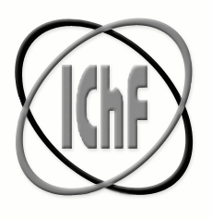


Institute of Physical Chemistry
Polish Academy of Sciences

Interdisciplinary NAnoscience School: from phenoMEnology to applicationS
[NaMeS] 711859 — NaMeS — H2020-MSCA-COFUND-2015/H2020-MSCA-COFUND-2015

……………………………..
(date)

To whom it may concern

The Institute of Physical Chemistry of the Polish Academy of Science, Warsaw, Poland (IPC PAS) certifies that ………………….. (Name and Surname), born in ………….. (country) on ………… (date of birth), bearer of the passport …………… (passport number), is employed at a PhD student position under NaMeS project (MSCA-COFUND) at IPC PAS from the …………… (day/month/year - starting date of the employment contract) till the …………………….. (day/month/year – date of termination of the employment contract)
…………………(Name and Surname) is employed in full-time, five days per week, with the monthly gross salary EUR 2,597 (incl. employer’s contributions to social security service - ca. avg. EUR 1,620 net, i.e. after all deductions). This monthly salary is paid throughout whole duration of the contract of employment including duration of the secondments.
The employment is funded by the European Union’s Horizon 2020 research and innovation programme under the Marie Skłodowska - Curie grant agreement No. 711859 and the Polish Ministry of Science and Higher Education, from the funds for science – an international co-funded project, grant agreement No. 3549/H2020/COFUND/2016/2.
This certificate is issued on request of the employee.

Deputy Director

Jacek Gregorowicz Professor Associate

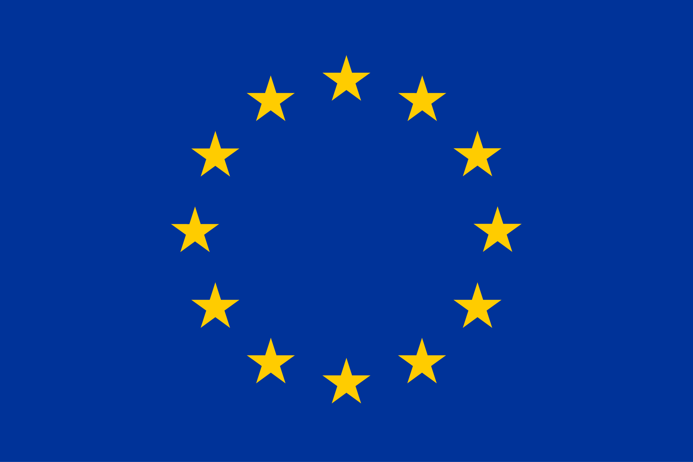
This project has received funding from the European Union’s Horizon 2020 research and innovation programme under the Marie Skłodowska-Curie grant agreement No. 711859.

